# Chapter 1: The ABC of Programming

-A script is a series of instructions that a computer can follow to achieve a goal.

-To write a script, you need to 1st state your goal and then list the tasks that need to be completed in order to achieve it:  
+Define the goal.

+Design the script.

+Code each step.

-Designing a script: tasks: The high-level view of tasks can be presented using a flowchart.

-Designing a script: steps: When you ready to code the script, steps can then be translated into lines of code.

-The document object represents an HTML page. Using document object, we can access and change what content users see on page and respond. Like other objects, document has: properties + methods + events

-How a browser sees a web page

+The browser receives an HTML page

+It creates a model of page and store it in memory.

+It shows the page on screen using a rendering engine (may use CSS)

-How HTML, CSS & JavaScript fit together

+HTML (Content Layer): give the page structure and adds semantics

+CSS (Presentation Layer): enhances the HTML page with rules that state how HTML content is presented

+JS (Behavior Layer): where we change how the page behaves, adding interactivity.

-Progressive enhancement: 3 layers form the basis of this popular approach to building web page: Start with HTML, then add CSS rules, JS is added last.

-Sample code: www.javascriptbook.com

-Creating a basic JS:

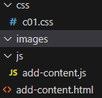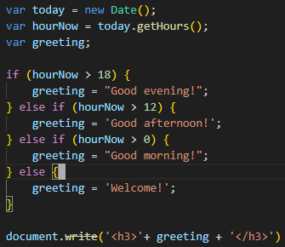

-Linking to a JS file from HTML page: Use <script src>

# Chapter 2: Basic JavaScript Instructions

# Chapter 3: Functions, Methods & Objects

# Chapter 4: Decisions & Loops

# Chapter 5: Document Object Model

# Chapter 6: Events

# Chapter 7: jQuery

# Chapter 8: Ajax & JSON

# Chapter 9: APIs